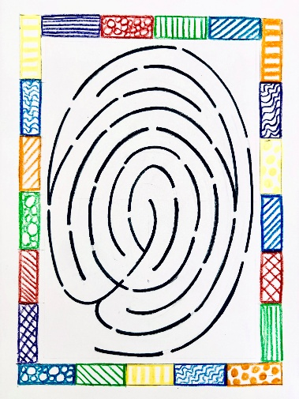

Public Fingerprint Labyrinth Locations
Monday, September 28th @ 4:00 – September 30th @ 4:30
Five Oaks Retreat Center
1 Bethel Road, Paris, Ontario
Contact – The Hospitality Team - hospitality@fiveoaks.on.ca
Friday, October 2nd @ 7-9 pm
First-St. Andrew’s United Church
350 Queens Ave, London, Ontario
Contact – The Rev. Dr. Joshua Lawrence – pastorjoshua@fsaunited.com
Wednesday, October 7th @ 7-9 pm
Crescent Fort Rouge United Church,
525 Wardlaw Ave, Winnipeg, Manitoba
Contact – The Reverend Marc Whitehead - marc.cfruc@mymts.net
Thursday, October 8th@ 10 am
Center for Christian Studies
60 Maryland St, Winnipeg, Manitoba
Contact – Elaine Bishop - e.bishop@shaw.ca
Saturday, October 10th @ 1-3
Canadian Memorial Center for Peace
1825 W 16th Ave, Vancouver, British Columbia
Contact – Cathy Merchant - programs@canadianmemorial.org

Sunday, October 11th @ 7 pm
St. Andrew’s-Wesley United Church
Suite 100, 1022 Nelson Street, Vancouver, B.C.
Contact – The Reverend Dan Chambers - rev.chambers@standrewswesley.com
Thursday October 15th @ 4:00 pm – Sunday, October 18th 11:00 am
Naramata Center
460 Ellis Avenue, Naramata, British Columbia
Contact – Jacquie Carlson - programs@naramatacentresociety.org
Friday, October 23rd @ 3-6:30 pm
St. Andrew's Presbyterian Church
703 Heritage Drive, SW, Calgary, Alberta
Contact – The Reverend Laurie McKay - lmckay@standrewscalgary.ca

The Fingerprint Labyrinth will also join the Canadian Peace Train in Edmonton, Alberta and be used at stops on the way to Parliament Hill in Ottawa.

